VIETNAM / FMCG CATEGORY INTELLIGENCE

Worship & Ritual Offerings:
FMCG Categories, Brands & Products
A complete occasion- and region-led competitive landscape | October 2026
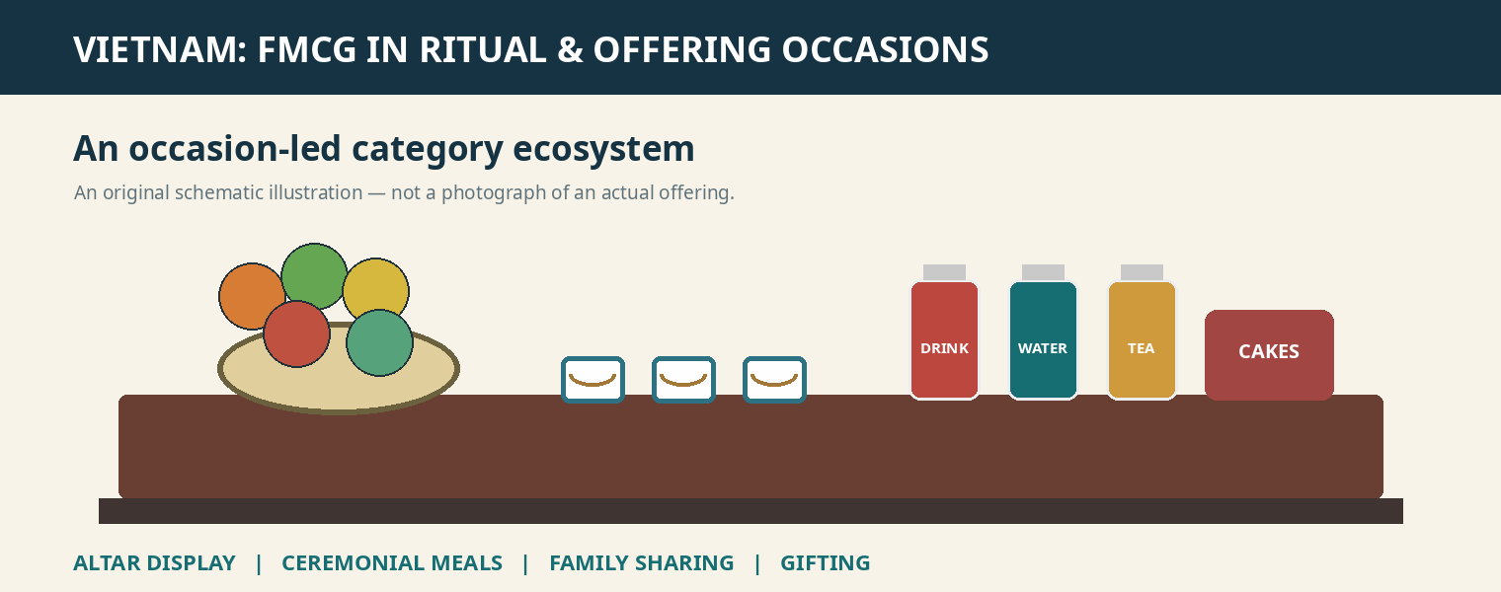
Original editorial schematic: ritual display, ceremonial meals, family sharing and seasonal gifting. Not a documentary photograph.
Purpose: Map which food and beverage categories are connected to Vietnamese worship-related occasions, which brand portfolios compete in each, and how the associated consumption roles differ. This document retains the full brand/category, occasion, regional, and role frameworks of the research response.
Evidence note: This is a documented competitive universe, not a statistically measured ranking of ritual-offering sales. “Leading” denotes broader Vietnamese category prominence when supported; example products and brands should not be interpreted as verified leadership specifically in ritual purchasing.

Executive synthesis
Worship-related purchasing in Vietnam is not a single “Buddhist offerings” category. It comprises Buddhist practices, ancestor veneration, monthly lunar observances, Tết, family death anniversaries, prosperity-related ceremonies and important annual festivals. For FMCG suppliers, the same product may be displayed on an altar, used to prepare a ceremonial meal, served afterwards to family, or purchased as a seasonal gift. These four roles create different competitive sets.
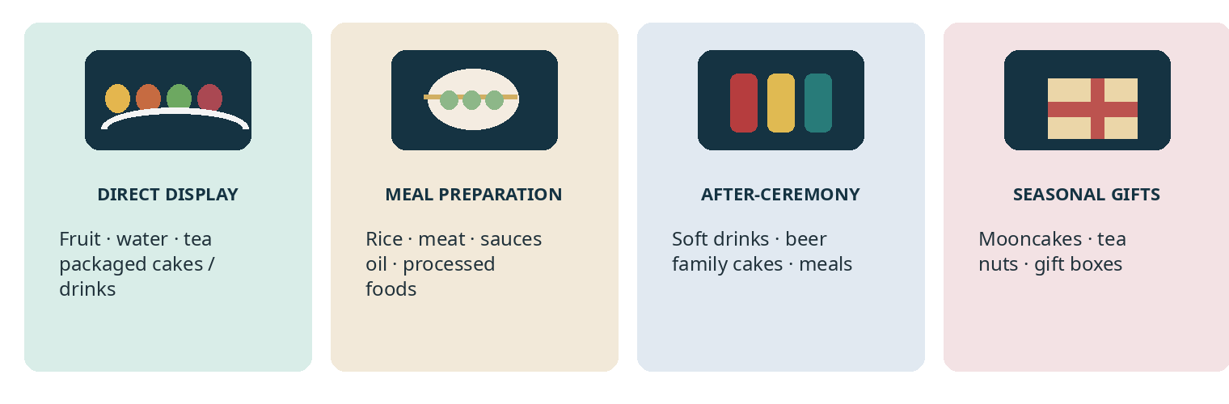
Figure 1. Four product roles. Illustrative product schematics; not actual product photography.

The 12 FMCG categories with the most useful competitive relevance
Category | Indicative role / occasions | Interpretation
Soft drinks | Tết, ancestor rituals, family feasts | Branded display in some homes; broad hospitality relevance
Biscuits / confectionery | Tết, periodic offerings, family sharing | Strong packaged brand universe
Mooncakes / traditional cakes | Trung Thu, Tết, ancestor offerings | Occasion-defined product formats
Tea / coffee | Monthly offerings, ancestor remembrance, guests | Tea is widespread; coffee appears in some contemporary settings
Bottled water | Routine altar care, visits, monthly rituals | Cross-occasion replenishment relevance
Prepared foods / meat | Tết, giỗ, prosperity ceremonies | Ingredients and ceremonial meals
Vegetarian foods | Rằm, Vu Lan, Buddhist eating | Prepared offering trays versus everyday vegetarian foods
Beer | Tết, giỗ and some folk/ancestor settings | Primarily feast/hosting; not general Buddhist Buddha offerings
Dried fruit / nuts | Tết, gifts, hospitality | May support display but evidence is more gifting/consumption-led
Packaged fruit | Tết, monthly altars, ancestral rituals | Often local and unbranded
Cooking staples | Ceremonial food preparation | Indirect category role; not displayed as offerings
Dairy / nutrition drinks | Family consumption around celebrations | Peripheral to direct worship

1. Evidence: FMCG products actually appear in ceremonies
Two photographed 2026 settings are especially useful. A VietnamPlus Tết ancestor altar photograph visibly includes red Coca-Cola cans alongside fruit and other products. A Vietnam Beer–Alcohol–Beverage Association report shows an altar arrangement containing branded beverages and packaged food, including Fanta, Trúc Bạch beer, Saigon Chill beer and a G7 coffee box. These images demonstrate real placement, but do not reveal national penetration or brand share.
Documented setting | Observed product types | What can be concluded
VietnamPlus, ancestor altar, Tết 2026 | Coca-Cola cans and other packaged goods near fruit and ceramic altar ware | Direct evidence of branded soft drinks in one household display
Vietnam beverage association, Tết 2026 | Fanta, beer cans, G7 box, packaged biscuits/cakes | Direct evidence of multiple modern FMCG categories in one ceremonial context
Saigon Co.op, Tết 2025 | Ready-prepared ancestor meals, vegetarian versions, pre-prepared fresh food; tam sên | Direct retailer commercialization of occasion-specific offerings
VietnamPlus, Vu Lan 2026 | Rising supplies of fruit, flowers, sticky rice, sweets, vegetarian food and ready-made offerings in Hanoi | Evidence of active specialist seasonal demand, not quantified branded share

Photo evidence: VietnamPlus ancestral altar (February 2026) View source
Photo evidence: Vietnam Beverage Association illustrated report (February 2026) View source
Retail evidence: Saigon Co.op government announcement (January 2025) View source
The links above open the original published photographs and retail case evidence. Photographic images are not reproduced here; embedded figures are original analytical illustrations.

2. FMCG category and brand universe
The following is a working market universe organised by FMCG category. It combines established broad-category brands with product lines relevant to the consumption context. “Example products” are portfolio signals, not a definitive exhaustive SKU census.
Category | Brand universe | Example product lines / formats | Occasion role
Carbonated soft drinks | Coca-Cola; Pepsi; Fanta; Sprite; 7UP; Mirinda | Coca-Cola Original Taste cans; Pepsi Cola; Fanta Orange; 7UP; Mirinda Orange | Tết display in some homes; family hospitality and feasts
Bottled water | Aquafina; La Vie; Dasani; i-on Life | Still water in small PET bottles, 350–600 ml; larger household formats | Routine water offerings, monthly observances, temple visits
Traditional tea | Cozy; Phúc Long; Vinatea; regional Thái Nguyên tea | Green tea; jasmine tea; lotus tea; tea bags; loose-leaf tea | Ancestral remembrance, monthly lunar rites, family hospitality
Coffee | G7 / Trung Nguyên; Nescafé; Vinacafé; Highlands Coffee | G7 3in1; G7 Pure Black; Nescafé 3in1; packaged instant coffee | Some contemporary ancestor altars; guests and gifts
Biscuits and cookies | Kinh Đô / Cosy; Orion; Bibica; Danisa; Richy; Hữu Nghị; Nabati; Mayora | Cosy Marie; Orion Gouté; Bibica Goody; butter-cookie tins; wafer boxes | Tết displays, sweets, family sharing and gifts
Packaged sponge cakes | Orion; Kinh Đô; Bibica; Hữu Nghị | ChocoPie; Custas; C’est Bon; Solite; Hura; Tipo | Documented packaged-cake altar use and household sharing
Confectionery | Bibica; Hải Hà; Tràng An; Alpenliebe; Mentos; Chupa Chups | Wrapped assortments; Cheery; Phát Tài; seasonal tins and jars | Tết candy trays, offerings in some homes, gifting
Mooncakes | Kinh Đô; Bibica; Hữu Nghị; Givral; Brodard; Như Lan; Bảo Phương | Baked/soft mooncakes; lotus; mung bean; mixed nuts; premium gift boxes | Trung Thu offerings, family sharing and gifts
Dried fruit | Vinamit; regional specialty producers; private labels | Dried jackfruit; banana; mango; mixed-fruit boxes | Tết gifting and hospitality; some displays
Nuts and seeds | Lafooco; Tân Tân; private labels; imports | Cashews; peanuts; almonds; sunflower seeds; mixed nuts | Tết gifts and household snack trays
Processed meat / foods | Vissan; Cầu Tre; local/supermarket prepared foods | Chả lụa; chả giò; lạp xưởng; marinated meat; fresh ceremonial foods | Tết ancestor meals and giỗ preparation
Vegetarian convenience | Acecook / Hảo Hảo; Vifon; vegetarian specialists | Vegetarian noodles; mushroom pho; tofu; ready-prepared chay dishes | Buddhist vegetarian eating and Vu Lan; direct trays often local
Cooking staples | CHIN-SU; Nam Ngư; MAGGI; Cholimex; Neptune; Simply; Meizan | Fish sauce; soy sauce; cooking oil; seasonings; chilli sauce | Indirect input to ceremony meal preparation
Dairy / nutrition | Vinamilk; TH true MILK; Dutch Lady; Milo | UHT milk; flavoured milk; nutrition drinks | Family gathering and hospitality; peripheral altar role
Beer | Bia Saigon; Tiger; Heineken; Hanoi Beer; Trúc Bạch; Huda; Larue | Saigon Lager; Saigon Special; Saigon Chill; 333; Tiger; Heineken | Tết/giỗ feasts, some ancestor or folk displays
Fresh fruit | Unbranded growers/traders; WinEco; Co.op; premium fruit retailers | Bananas; pomelos; oranges; apples; mangoes; coconuts; region-specific sets | Fundamental direct offering category, fragmented branding

Brand notes: Coca-Cola’s documented category prominence comes from Worldpanel household choice data; Bibica and Orion product-specific listings are verified through their official portfolio pages. Fresh fruit and traditional prepared foods remain largely fragmented.

Company concentration versus ceremony relevance
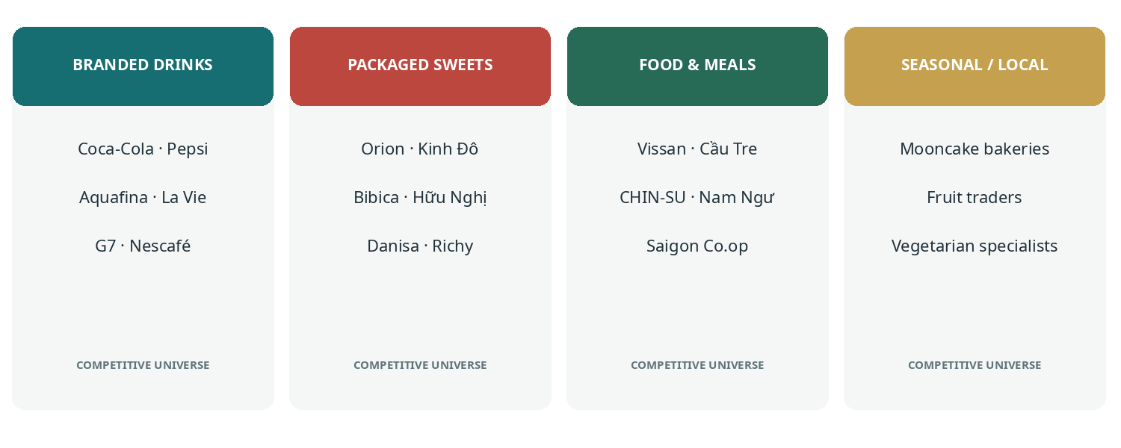
Figure 2. Competitive universes by category role. Brand names illustrate relevance and are not rankings of ritual sales.
Coca-Cola was the most chosen beverage brand across Kantar’s Urban 4 and rural Vietnam panels in the 2023 ranking; Tiger and Bia Saigon were significant urban and rural beverage brands respectively, and G7 and Nescafé appeared in the urban beverage ranking. This is broader household-purchase evidence, not ceremony-specific leadership.
Worldpanel / Kantar Vietnam Brand Footprint 2023 View source
Worldpanel 2025 national FMCG overview View source

3. High-relevance brand portfolios

Orion Vina | Packaged cakes, biscuits and festive assortments
ChocoPie, Gouté, Custas and C’est Bon straddle shelf-stable household snacking, ceremonial display in selected settings, gifting and family consumption. An official ChocoPie watermelon Tết gift box containing 16 cakes (448 g) is a concrete example of seasonal format architecture.
Orion official: ChocoPie Watermelon Tết gift box View source

Mondelez Kinh Do | Biscuits, bakery snacks and mooncakes
Kinh Đô mooncakes sit within a clear annual Trung Thu category; Cosy, Solite and AFC add year-round packaged snack exposure. A brand can therefore participate in both a highly specialized seasonal category and broader everyday sweets buying. Not all of those purchases are religious offerings.

Bibica | Tết-specific pack architecture
Bibica’s 2026 Tết catalogue separates metal tins, plastic boxes, paper boxes, gift boxes, Goody cookies, Cheery sweets and Phát Tài candies. Examples listed by Bibica include Goody Classic assorted cookie tins in multiple sizes, Cheery fruit-filled hard-candy boxes, and Phát Tài sweets with prosperity-oriented formats. This portfolio provides unusually clear product-level evidence of seasonal specialization.
Bibica official: 2026 Tết product catalogue View source

Trung Nguyên G7 | Instant coffee as contemporary packaged offering / hospitality
G7 3in1, Pure Black and other ready-portioned coffee products belong primarily to beverage use and household hospitality, but photographed branded coffee on a Tết altar demonstrates an additional possible display role. The evidence supports presence in some settings, not a universal tradition.

Vissan and Saigon Co.op | Ritual meals and occasion-ready food
Vissan’s packaged meat universe is relevant to preparation of ceremonial family meals. Saigon Co.op has explicit evidence of occasion-specific products, including ancestral offering trays in vegetarian and non-vegetarian versions, and ready-prepared tam sên. In contrast with packaged snacks, these products directly address assembling the ritual meal.
Saigon Co.op official/public-sector description of 2025 seasonal assortments View source

4. Occasion × category intelligence
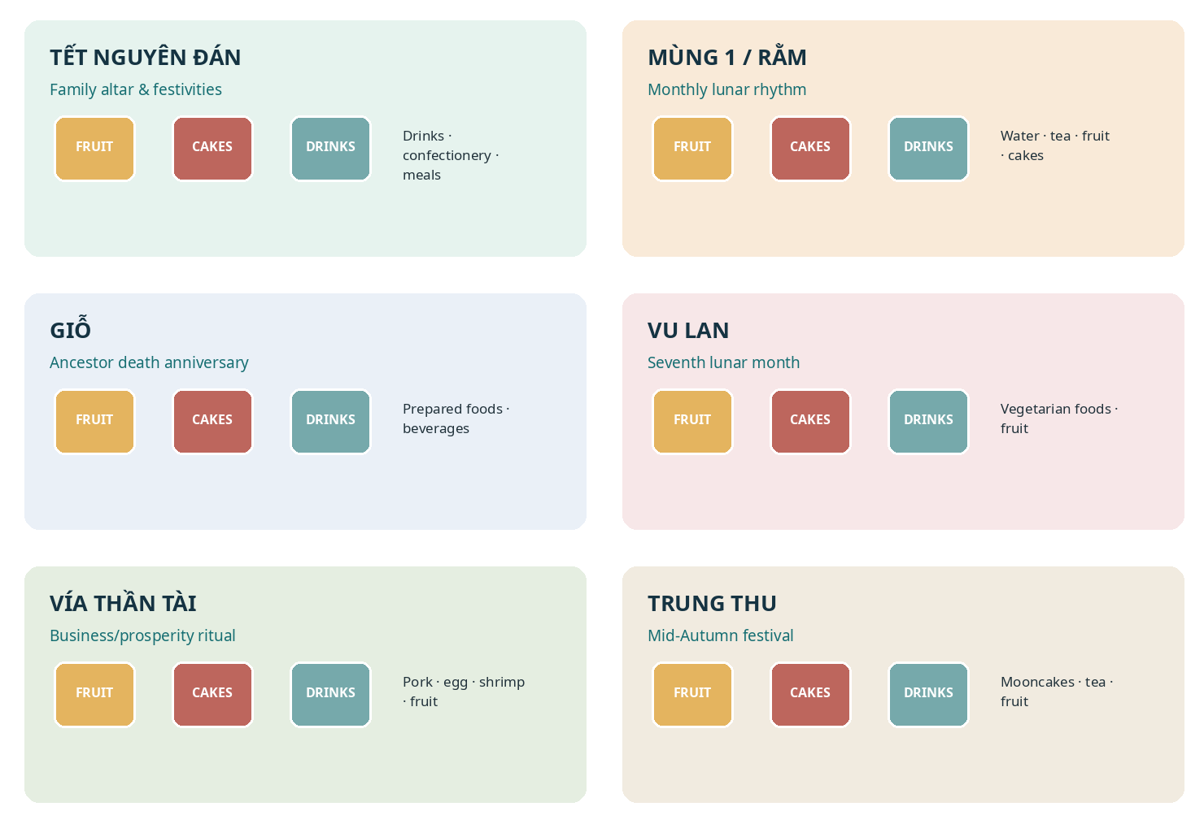
Figure 3. Six principal occasion clusters. Original illustrative cards, not photographs or packshots.

A. Tết Nguyên Đán
The broadest FMCG basket in the study. Ancestral display, hospitality, gift-giving and ceremonial meals occur together but should be separated analytically.
Categories: Soft drinks, beer, confectionery, biscuits, dried fruit, nuts, cakes, prepared foods, cooking staples.
Relevant brand universe: Coca-Cola, Pepsi, Orion, Kinh Đô, Bibica, Danisa, Vinamit, Lafooco, Vissan, Saigon Co.op, Bia Saigon, Tiger.
Representative products: Coca-Cola cans; ChocoPie; Cosy biscuits; Goody cookie tins; wrapped candies; dried fruit; bánh chưng / bánh tét; chả lụa; ready-made meal trays.

B. Mùng 1 and Rằm
Recurring first and fifteenth lunar-day observances; generally smaller and more frequent purchase baskets than Tết.
Categories: Fruit, bottled water, tea, flowers, sometimes cakes and vegetarian foods.
Relevant brand universe: Aquafina, La Vie, Cozy, regional tea suppliers and locally made cakes.
Representative products: Small water bottles; green/lotus tea; fruit; simple cakes; vegetarian products depending on household.

C. Giỗ | Ancestor death anniversary
Household-specific family commemoration that can involve an elaborate meal, guests and remembrance rituals.
Categories: Rice, meat, processed foods, sauces, tea, bottled water, soft drinks, beer, occasionally sweets.
Relevant brand universe: Vissan, Cầu Tre, CHIN-SU, Nam Ngư, Cholimex, Neptune, Coca-Cola, Pepsi, regional beer brands.
Representative products: Chả lụa; chả giò; cooked meat; rice; prepared family dishes; tea and hosting beverages.

D. Vu Lan / Rằm tháng Bảy
Combines Buddhist observance, filial gratitude and ancestor remembrance. Need to distinguish vegetarian household eating from foods placed on an altar.
Categories: Prepared vegetarian meals, tofu, mushrooms, rice dishes, chè, fruit, tea, water.
Relevant brand universe: Local vegetarian specialists and supermarkets; Vifon/Hảo Hảo vegetarian convenience products for adjacent home eating.
Representative products: Vegetarian ceremonial trays, tofu/mushroom dishes, sticky rice, fruit, tea; vegetarian noodles more often consumption products.

E. Vía Thần Tài
Tenth day of the first lunar month; household/business prosperity observance rather than a Buddha offering.
Categories: Pork, eggs, shrimp/crab, fish, fruit, tea, water and prepared offering sets.
Relevant brand universe: Vissan, fresh markets, supermarkets and local preparers; Saigon Co.op’s ready tam sên is directly relevant.
Representative products: Bộ tam sên, roast/boiled meat or fish in some regions, fruit and drinks.

F. Tết Trung Thu
The most product-specialized sweet-cake occasion, involving offerings in some households as well as substantial gifting and family consumption.
Categories: Mooncakes, tea, fruit, gift confectionery.
Relevant brand universe: Kinh Đô, Bibica, Hữu Nghị, Bảo Phương, Givral, Brodard, Như Lan, Đồng Khánh, Đại Phát.
Representative products: Bánh nướng, bánh dẻo; mixed-nut/lotus/mung-bean fillings; gift boxes; tea.

Other significant occasions
Occasion | Product mix | Most relevant FMCG competitive lens
Ông Công Ông Táo | Ceremonial dishes, sticky rice, fruit, cakes, water/tea | Traditional prepared foods, ingredients, local sellers and supermarkets
Rằm tháng Giêng | Fruit, tea, water, vegetarian foods, sweets | Water, tea, vegetarian dishes and specialist local foods
Phật Đản / Vesak | Fruit, flowers, tea, water, vegetarian food | Bottled water and tea, fruit, vegetarian specialists
Đoan Ngọ | Fermented sticky rice, seasonal fruit, traditional cakes | Local/independent specialty producers
Khai trương / opening ceremony | Fruit, coconut, flowers, sweets, drinks, sometimes meat dishes | Fresh suppliers, soft drinks, prepared ceremonial sets
Routine Thần Tài altar care | Water, tea, fruit, sweets, occasional coffee | Water, tea, coffee and confectionery competitors

VietnamPlus: Vu Lan ready-made offering and online-delivery demand (August 2026) View source

5. Occasion × category relevance matrix
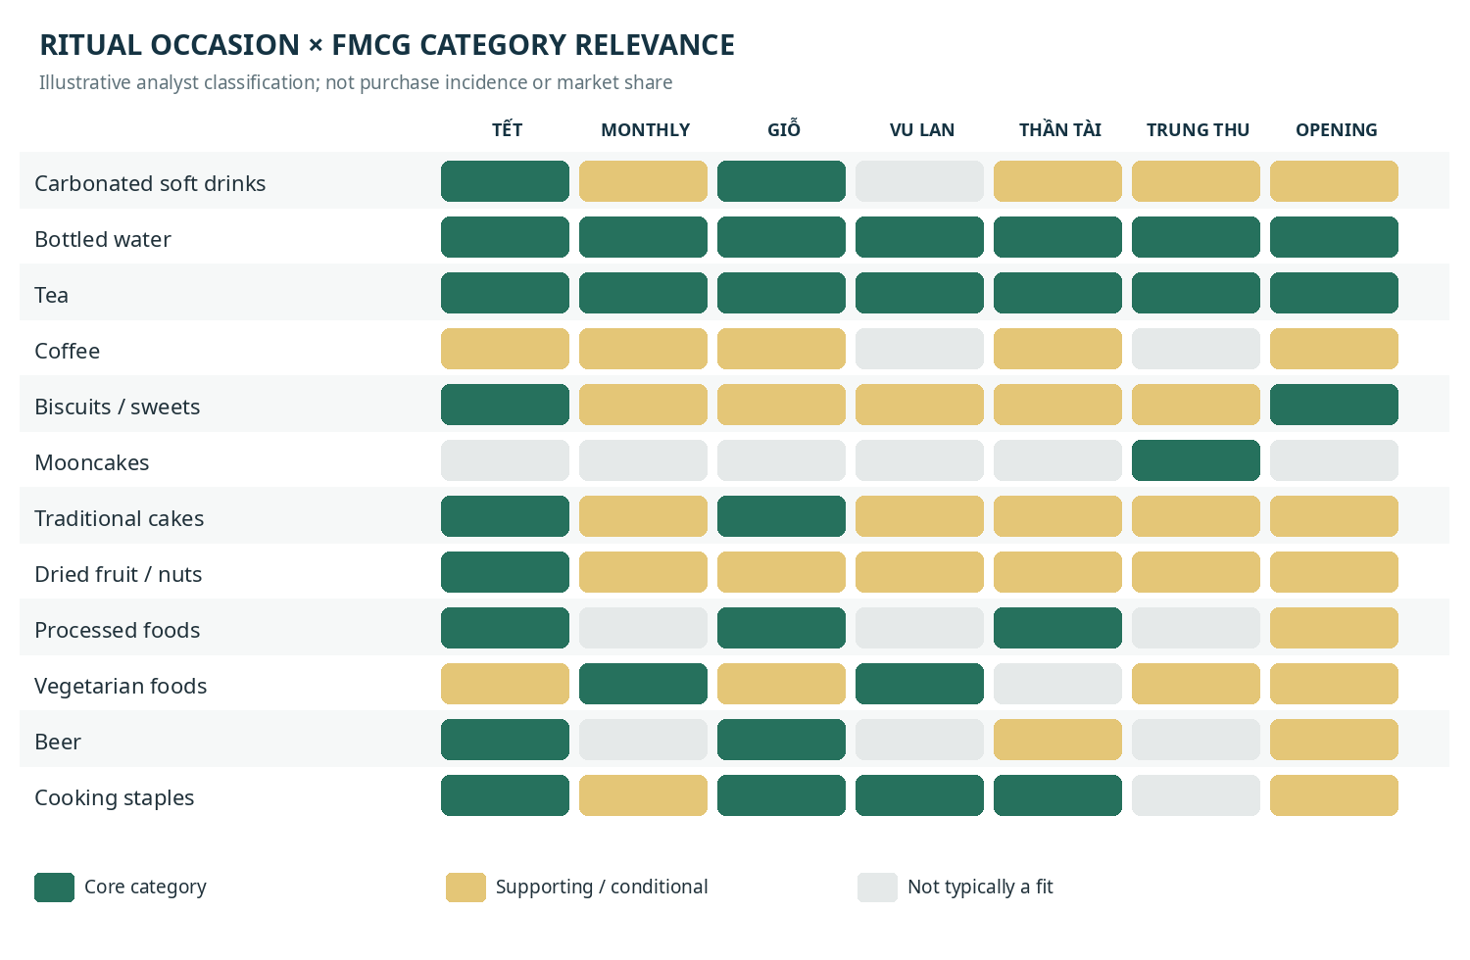
Figure 4. Qualitative analyst heatmap. Green = core/recurrent relevance; amber = secondary or conditional; grey = not a typical fit. This is not measured penetration or sales.
Water and tea are relevant across many observances, whereas mooncakes are tightly concentrated around Trung Thu. Cooking staples play a supporting role in meal preparation even where they are not displayed directly. Beer must be differentiated between family feasts, ancestor/folk altars and Buddhist temple/Buddha offerings.

6. Regional FMCG distinctions
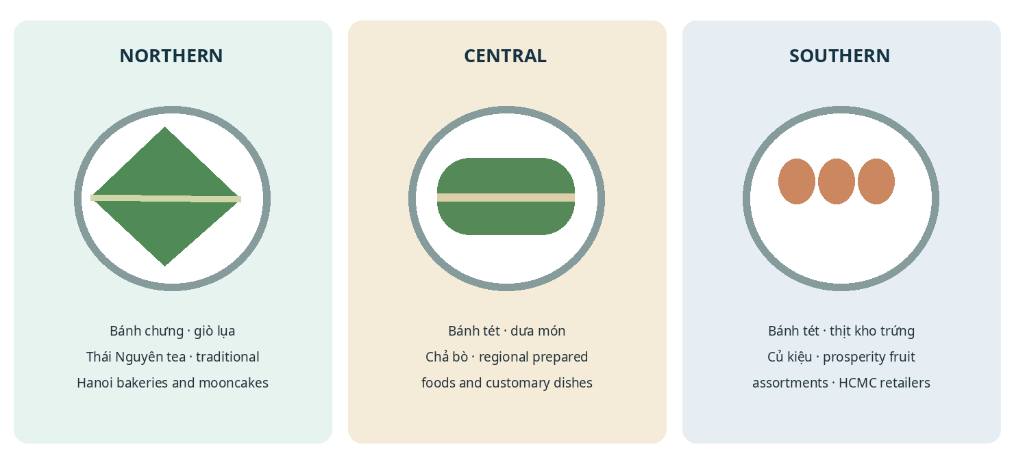
Figure 5. Three regional food repertoires. Schematic illustrations; regional specifics vary by household and province.
Dimension | North | Central | South
Tết core foods | Bánh chưng, giò lụa, thịt đông, dưa hành | Bánh tét, dưa món, chả bò and local preserves | Bánh tét, thịt kho trứng, củ kiệu, canh khổ qua
Fruit displays | Bananas, pomelo, citrus and seasonal fruit | Varies strongly by local supply and custom | Mãng cầu, dừa, đu đủ, xoài in prosperity-themed assortments
Tea / coffee | Green tea and Thái Nguyên heritage | Green tea and regional specialties | Tea plus strong coffee/hospitality consumption
Packaged sweets | Kinh Đô, Bibica, Hữu Nghị, Hải Hà, Tràng An | National FMCG and local traditional producers | Orion, Kinh Đô, Bibica, Hữu Nghị, imports
Mooncakes | Kinh Đô, Hữu Nghị, Bibica, Bảo Phương | National brands and regional bakers | Kinh Đô, Givral, Brodard, Như Lan, Đồng Khánh, Đại Phát
Beer at family feasts | Hanoi Beer, Trúc Bạch, Tiger, Heineken | Huda, Larue, Bia Saigon | Bia Saigon, Tiger, 333, Heineken
Retail ecosystem | Traditional markets, specialist bakers, supermarkets | Regional specialty sellers and food markets | Traditional markets, supermarkets, ready-prepared trays

These are regional watchlists, not measured regional ritual-sales rankings. National brands have broad availability, while traditional bakery and fresh-prepared categories are structurally more localized. Local producers can be much more relevant than national leaders for specific dishes.

7. Product role classification: avoid double counting
Product role | What is actually bought | Example categories / brands | Caution
Direct offering display | Something placed on altar or ceremonial table | Fruit; water; tea; some Coca-Cola and Orion packs | Observed in some homes does not mean a universal rule
Ceremonial meal preparation | Ingredients/processed foods prepared and offered | Vissan; Cầu Tre; CHIN-SU; Nam Ngư; cooking oil | Ingredients themselves are often not displayed
Post-ceremony hosting | Consumed after ritual by household and guests | Soft drinks; beer; cakes; full meals | Do not count all hosting as direct offerings
Occasion-season gifting | Purchased for gifting to family/business contacts | Mooncakes; premium tea; nuts; boxed confectionery | Not necessarily intended for an altar

A single SKU can participate in multiple roles; for instance, canned beverages could appear on an ancestral altar and later be offered to guests. A single annual occasion may therefore produce overlapping but analytically distinct sales drivers.

8. Manufacturer and portfolio mapping
Company / brand owner | Brands / ranges | Competitive connection
Coca-Cola Vietnam | Coca-Cola, Fanta, Sprite, Dasani | Branded drinks; occasional altar displays; hospitality
Suntory PepsiCo Vietnam | Pepsi, 7UP, Mirinda, Aquafina, Sting | Soft drinks and water; Tết/household consumption
Mondelez Kinh Do | Kinh Đô, Cosy, Solite, AFC, Oreo | Biscuits, cakes and mooncakes
Orion Vina | ChocoPie, Gouté, Custas, C’est Bon | Packaged cakes, biscuits, gift boxes
Bibica | Goody, Hura, Cheery, Phát Tài, mooncakes | Confectionery, cookies, festival season products
Hữu Nghị Food | Hữu Nghị, Tipo, mooncakes | Biscuits, bakery snacks, mooncakes
Trung Nguyên Legend | G7, Trung Nguyên Legend | Instant coffee, gifts, guests
Nestlé Vietnam | Nescafé, Milo, MAGGI | Coffee, family consumption, cooking ingredients
Vinamilk | Vinamilk, Ông Thọ, Ngôi Sao Phương Nam | Dairy and prepared-dessert ingredients
Vissan | Fresh and processed meat products | Traditional ceremonial meal input
Masan Consumer | CHIN-SU, Nam Ngư, Omachi | Sauces, meal ingredients, noodles
Acecook Vietnam | Hảo Hảo (including vegetarian variants) | Convenience vegetarian eating
Vinamit | Vinamit dried fruit | Dried fruit and seasonal gifting
Lafooco | Lafooco nuts | Cashews, mixed nuts, gifts
Saigon Co.op | Co.op products, prepared-food services | Ready ritual assortments and meal trays

9. Strategic reading of the category landscape

Battleground 1 | Branded beverages and the ceremonial display
Coca-Cola and some other FMCG drinks have genuine photographed evidence of direct Tết altar presence, but the robust broad market ranking is about household purchasing rather than worship. Separate traditional tea/water offering occasions from more elaborate annual and folk ceremonial displays.

Battleground 2 | Packaged cakes and confectionery
Orion, Kinh Đô, Bibica and Hữu Nghị have broad product breadth across year-round snacks, annual festivals and family sharing. Bibica’s official 2026 Tết catalogue provides granular proof of tins, gifting boxes and prosperity-themed confectionery.

Battleground 3 | Ceremonial and ready-prepared meals
This landscape is shared by national processed-food brands, wet markets, traditional prepared-food businesses and supermarkets. Saigon Co.op’s meal-tray services show that this need can be packaged into a directly occasion-specific retail proposition.

Battleground 4 | Vegetarian foods around Buddhist festivals
The commercial universe includes fresh local vegetarian dish specialists, supermarkets, tofu and mushroom suppliers, and convenience-food brands. Inference must remain disciplined: a widely sold vegetarian instant noodle is not automatically an altar offering, although it may be part of associated food consumption.

Battleground 5 | Mooncakes, fruit, nuts and seasonal gifting
A more fragmented competition set. Established mooncake manufacturers are highly visible, while fresh fruit, traditional cakes and ceremonial specialties frequently rely on independent and regional businesses. Gift consumption and ritual usage overlap but are not synonymous.

10. Verified source and photography reference directory
The original web articles below include actual photographs of offerings or real manufacturer product imagery. The illustrations embedded in this report are original analytical graphics rather than republished third-party photos. Use the source links for documentary reference and image licensing/permissions if reproducing photographs externally.
01. VietnamPlus | Photograph of Coca-Cola on a Tết ancestor altar | February 2026 — Open
02. Vietnam Beer–Alcohol–Beverage Association | Branded offerings photograph | February 2026 — Open
03. Vietnam Pictorial / VNA | Traditional Tết ancestral altar photograph | February 2026 — Open
04. VietnamPlus | Hanoi Vu Lan prepared offerings and delivery | August 2026 — Open
05. Saigon Co.op | Ready ancestral offering trays | January 2025 — Open
06. Saigon Co.op | Ready tam sên and ancestral sets | December 2024 — Open
07. Orion Vina | Official ChocoPie Tết Watermelon gift product — Open
08. Bibica | Official 2026 Tết cookies and confectionery catalogue — Open
09. Worldpanel | Vietnam Brand Footprint 2025 — Open
10. Kantar Worldpanel | Vietnam beverage brands 2023 — Open
11. Vietnam Beverage Association | Tết 2026 beverage assortments and brand packs — Open
12. Regional offerings / giỗ meal preparation imagery | Điện Máy Xanh — Open
13. Vu Lan illustrative vegetarian feast photo | FPT Shop — Open
14. Givral 2026 | Available seasonal catalogue via distributor — Open

11. Quick-reference: products to track by occasion
This practical reference separates products photographed in ceremonies or explicitly sold as ritual solutions from brands whose category portfolio makes them relevant but whose ritual use has not been independently measured.
Occasion | Brand / supplier | Named product or assortment | Evidence designation
Tết altar | Coca-Cola | Coca-Cola red canned beverage | Observed in published altar photograph
Tết altar | Orion / assorted packaged snacks | ChocoPie, Gouté-type packaged cakes | Product category / photographed historical example
Tết altar | Fanta, G7, Saigon Chill, Trúc Bạch | Branded cans and coffee packs | Observed in published 2026 ceremony image
Tết gift/hosting | Orion | ChocoPie Watermelon Tết 16-piece, 448 g | Verified official seasonal product
Tết gifting | Bibica | Goody Classic cookie tins | Verified official 2026 portfolio
Tết sweets | Bibica | Cheery candy, Phát Tài candy | Verified official 2026 portfolio
Tết ancestral meal | Saigon Co.op | Ready ancestor meal tray, vegetarian/savoury | Verified occasion-specific retail offer, 2025
Thần Tài | Saigon Co.op | Ready tam sên assortment | Verified occasion-specific retail assortment
Giỗ meal | Vissan / Cầu Tre | Chả lụa, chả giò, processed foods | Category-relevant product candidate
Rằm / monthly | Aquafina / La Vie | Still drinking-water bottles | Category-relevant product candidate
Vu Lan | Local vegetarian specialists | Prepared vegetarian offering trays | Documented category demand; fragmented suppliers
Vu Lan home eating | Vifon / Hảo Hảo | Vegetarian noodles / mushroom pho | Adjacent consumption, not confirmed offering
Trung Thu | Kinh Đô / Bibica | Baked and soft mooncakes | Occasion category leadership candidates
Trung Thu, HCMC | Givral / Brodard / Như Lan | Traditional and premium mooncake gift boxes | Established local brands / broader seasonal trade

Interpretive safeguards / limitations
• No public source reviewed establishes a national share-of-offering ranking for Coca-Cola, Orion, Kinh Đô or other major brands; reported broader category leadership must not be relabelled as religious-occasion leadership.
• Ritual practice varies among Buddhism, ancestor worship and folk-deity offerings, across regions and households. Meat and alcoholic drinks do not belong in an undifferentiated “Buddhist offerings” assortment.
• Some listed categories are adjacent to ritual activity rather than altar-displayed products: cooking ingredients, dairy, vegetarian convenience foods and most festive hospitality purchases.
• The heatmap is a structured qualitative assessment; it is not quantitative share, sales, weighted distribution, incidence, or ranking data.
• Brand and product examples indicate market participation or availability at the time of research; individual SKUs and seasonal packaging may change.

